Date | 30 September 2026
Team ID | 6ab4dd7a6f290be8a6b49f92
Project Name | Script-Controlled ACL – Restrict Record Access Based on Field Value
Maximum Marks | 3 Marks

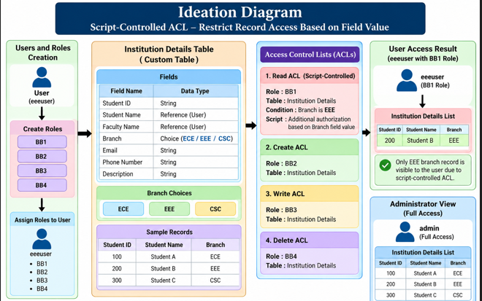

Ideation Diagram – Description
The Ideation Diagram presents the ideas generated by the team for improving record security in the ServiceNow application. The brainstorming focused on controlling access to the Institution Details table using field-based conditions, creating separate roles for Read, Create, Write, and Delete operations, and testing access using ECE, EEE, and CSC branch records. After evaluating the proposed ideas, the team selected the Script-Controlled ACL based on the Branch field as the main solution because it directly addresses the requirement to restrict unauthorized record access.

